# Step 3 – Introduction of Istio

## Composition diagram

This step's goal is to configure the application to run with Istio as a service mesh, as shown in the diagram below.

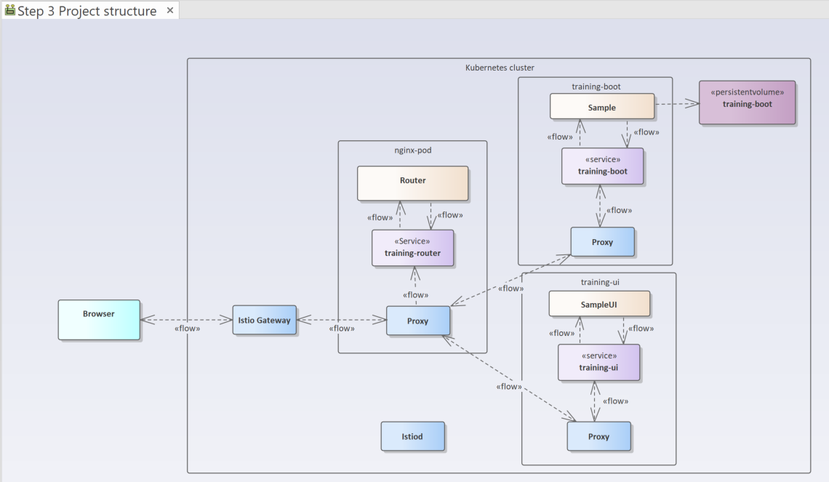

This allows for the control of traffic between various application components and exposes the deployment to external users.

## Preliminary steps

Install Istio into the Kubernetes cluster if it is not there yet. Use the scripts provided

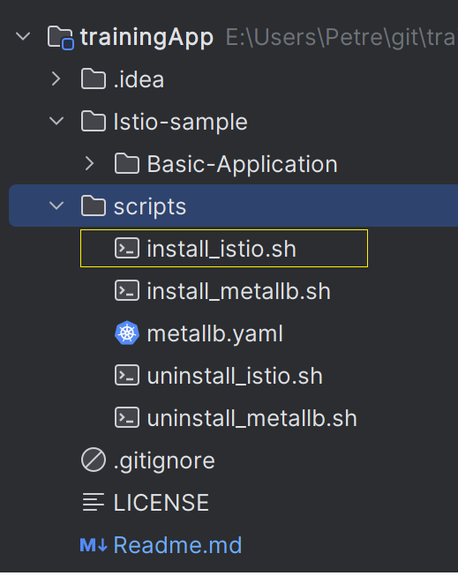

For a bare-bone Kubernetes cluster other than Minikube, the open-source Load Balancer MetalLB can also be installed using a provided script.

### Small code change

Envoy from Istio does not like traffic on HTTP 1.0, which is used by the routing server (nginx) by default.

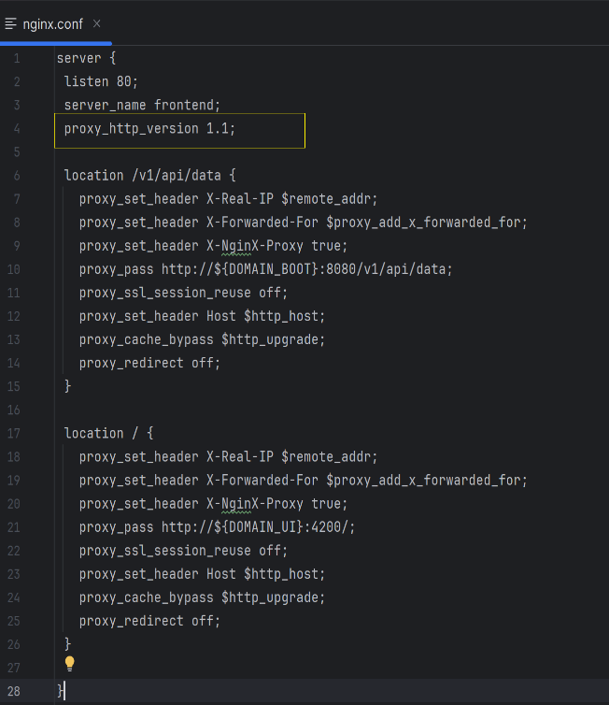

## The Charts with Istio

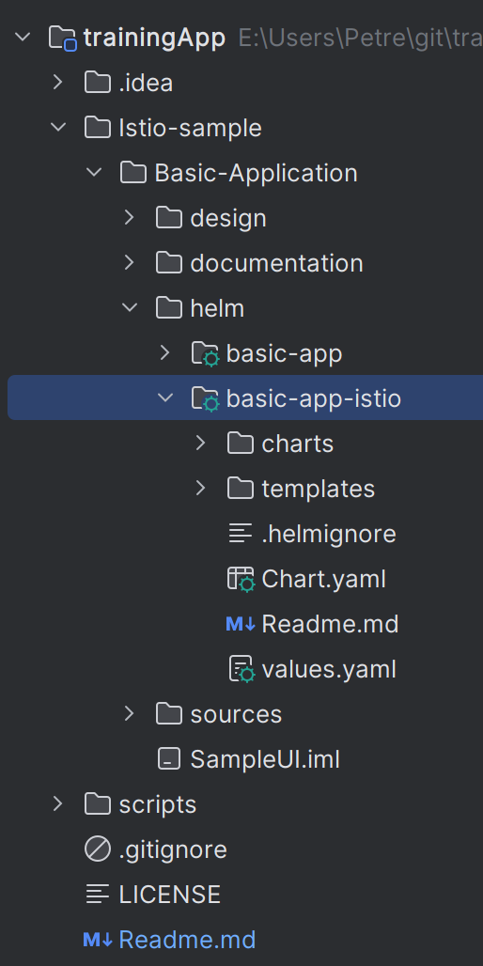

Install it running

* helm install sample basic-app-istio –atomic

Validate istio configuration:

* istioctl analyze -n sample